Voting System for COC Student Elections


A Research Paper
ITE 186/399
Presented by:

AGUILAR, ARJIE CARGED N. | HILADO, EFRELL CANOY
BANIEL, JOHN PAUL | PAGARA, ELFRANCE APUGAN
BOCTOT, JOHN CORONEIL | SANTURONI, MERRIJEAN TREYA
CABILTO, MICO VINCE | TARAY, CIELBERT JAMES
GUANZON, MARK DEMATA

April 20, 2026

  - Introduction

In today’s digital era, technology plays an important role in making everyday tasks faster, more accurate, and more accessible. According to Joseph and Ness (2023), the relationship between computers and society has significantly transformed, shaping the way people interact, communicate, and make decisions. One important area where technology can improve efficiency is in the conduct of elections. Voting is a crucial democratic process that allows individuals to express their choices and participate in leadership selection. As stated by the International Institute for Democracy and Electoral Assistance (International IDEA, 2015), elections are essential in promoting democratic representation and accountability. In educational institutions such as Cagayan de Oro College (COC), student council elections are important because they allow students to choose leaders who will represent their interests and concerns. However, traditional voting methods can be time-consuming and prone to errors. For this reason, the development of a Voting System for COC Student Council Election can help improve the voting process by making it more organized, efficient, and convenient for students.

In many schools, student elections are still conducted through manual processes such as paper ballots, tally sheets, and handwritten voter lists. While this method is commonly used, it often leads to difficulties in managing the election properly. According to ACE Electoral Knowledge Network (ACE Project, 2023), manual voting procedures can result in inefficiency, human errors, and delays in counting and reporting election results. In the case of COC student council elections, several issues may occur during manual voting. First, vote counting may take too long, especially when there are many students participating, causing delays in announcing the official winners. Second, the manual system increases the risk of errors in tallying votes, which may affect the accuracy of results. Third, the process of verifying voters can be difficult, as checking names manually may lead to confusion and possible double voting. These problems can affect the credibility and fairness of the election. As student populations increase, a faster and more reliable method becomes necessary to ensure that elections remain smooth and trustworthy.

The purpose of this study is to address the challenges experienced during the student council election process at Cagayan de Oro College. Some voting systems often result in delayed vote counting, inaccurate tallying, and difficulties in voter verification, which can reduce the efficiency and reliability of the election. To solve these issues, the proposed Voting System for COC Student Council Election aims to provide a more organized and secure way of conducting student elections through a digital platform. This system is designed to allow students to vote easily while ensuring that votes are properly recorded and counted. According to International IDEA (2015), the use of election technology can improve efficiency and strengthen trust in electoral processes when properly implemented. Similarly, the ACE Project (2023) highlights that computerized vote counting reduces human error and speeds up the announcement of results. Through this system, COC can achieve a faster election process, improve vote accuracy, and ensure proper voter validation, resulting in a more credible and convenient student election experience.

  - Statement of the Problem

General Problem

One of the main problems faced by both the election committee and students during the COC Student Council Election is the difficulty of ensuring that the voting process remains smooth, accurate, and user-friendly. Issues such as delays in vote processing, concerns in result accuracy, and challenges in voter verification may affect the efficiency and reliability of the election.

Specific Problem

• The election committee experiences difficulty in organizing and managing voter information, candidate details, and election records during the voting period.
The election committee may face challenges in handling voter lists, candidate profiles, and election records during the election period. Managing large amounts of information can take time and effort, especially when there are many participants. Mistakes in recording or organizing data may also occur, making the election process harder to manage efficiently.

• Issues such as incorrect voter validation and unauthorized voting may occur, which can affect the credibility and fairness of the election results.
Challenges in verifying eligible voters may happen during the election process. Some students may accidentally vote more than once, or unauthorized individuals may attempt to participate. These issues can affect the credibility and fairness of the election, which is why having a system that ensures proper voter validation is important.

• The process of vote tallying and result generation may take time and may be prone to errors, causing delays in announcing the official winners.
Vote tallying and result generation may take time, especially if the system is not fully automated. Delays in processing results can slow down the announcement of official winners and may affect student trust in the election process. Errors in counting votes may also require additional checking, which increases the workload of the election committee.

  - General Objectives

The main goal of this study is to develop a simple and organized voting system for COC student council elections to help both the election committee and students manage the voting process in a faster, more accurate, and more efficient way. The system aims to streamline voter verification, candidate management, and vote tallying, ensuring a smoother and more reliable election process.

  - Specific Objectives

- To design a simple feature that accurately records voter and candidate details.

- To develop a system that efficiently manages vote tallying and generates election results.

- To create a student dashboard that allows students to securely vote, track their voting status, and view election information.

Scope & Limitation

  - Scope

The proposed Voting System for COC Student Council Election is designed to simplify and automate the voting process for both the election committee and students using a web-based interface. It focuses on improving voter and candidate management, ensuring accurate vote recording and tallying, and providing students with convenient access to participate in elections.

  - Limitation

The proposed Voting System for COC Student Council Election is a simple web-based system designed for basic student council voting transactions. It is not connected to external systems or the internet, so it cannot support remote voting from outside the school network. The system does not include a full database backup, meaning all election data may be lost if the system is not properly maintained. It operates primarily in a single-school environment and lacks multi-institution support or advanced authentication systems. Additionally, it does not include features such as automated audit logs, analytics of voting patterns, or integration with student portals. These limitations make the system suitable for demonstration purposes and small-scale student council elections only.

  - System Requirements

Hardware Requirements

- Processor: 1 GHz or higher CPU.
- RAM: At least 128 MB.
- Storage: 10 MB free disk space.
- Input: Keyboard and/or mouse for navigation and voting.
- Output: Monitor or web browser display.
- Network: None required for offline use (internet optional for future online voting features).

Software Requirements

- Operating System: Windows, macOS, or Linux.
- Programming Language: HTML, CSS, JavaScript, and PHP (or your chosen web stack).
- Environment: Web browser (Google Chrome, Mozilla Firefox, Microsoft Edge, etc.).
- Runtime/Server: Local server such as XAMPP, WAMP, or MAMP for PHP processing.
- Dependencies: None required; uses standard web technologies and built-in browser features.

Election Committee Functional Requirements

- Record voter and candidate details: Input student voter information and candidate profiles.
- Manage votes: Verify and validate votes, ensuring only eligible students can vote.
- Tally votes and generate results: Automatically count votes and produce election results.
- View election records: List all voters, candidates, and vote counts with details in Admin.

Non-Functional Requirements

- Usability: The system provides clear instructions, prompts, and error messages to guide both students and the election committee.
- Reliability: Input validation ensures correct voter and candidate information, and prevents duplicate votes or entries.
- Security: Basic validation is implemented to maintain integrity of votes and prevent unauthorized access.
- Performance: The system performs fast operations for recording votes, tallying results, and updating dashboards in real-time.

Student (Voter) Requirements

- Cast vote: Submit votes for chosen candidates securely.
- View voting status: Check if their vote has been successfully recorded.
- View candidates: Access candidate profiles and election information.
- Navigate dashboard: Move through menus to perform voting actions easily.

Non-Functional Requirements

- Usability: Provides a clear and simple interface for students and the election committee to navigate the system easily.
- Reliability: Checks for duplicates, validates voter inputs, and ensures votes are recorded accurately.
- Accessibility: Supports case-insensitive matching for voter IDs and candidate names to reduce input errors.
- Performance: Performs fast searches and updates in lists of voters, candidates, and votes to ensure smooth operations.

  - Flowchart
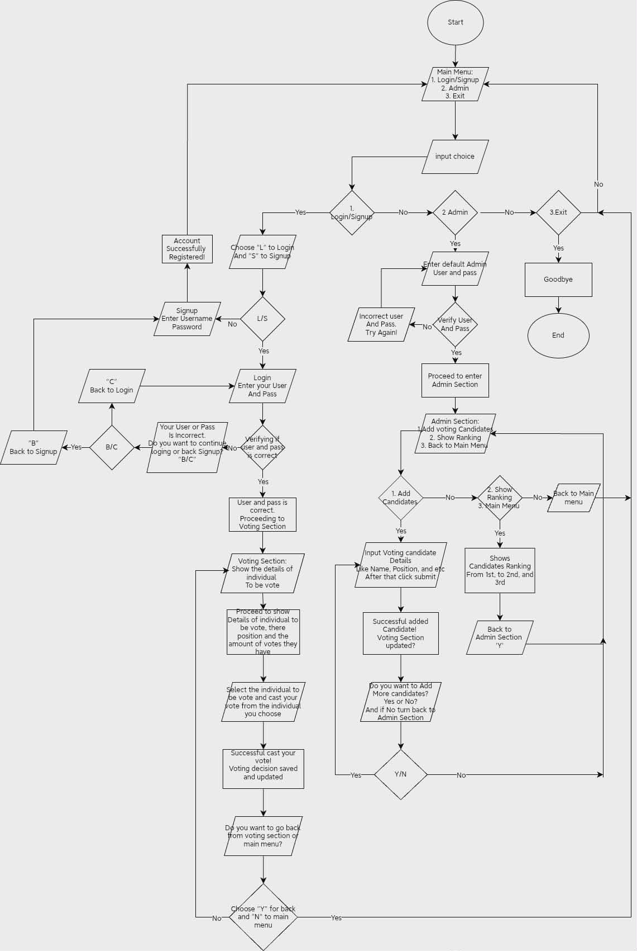

  - Code Snippet of Voting System

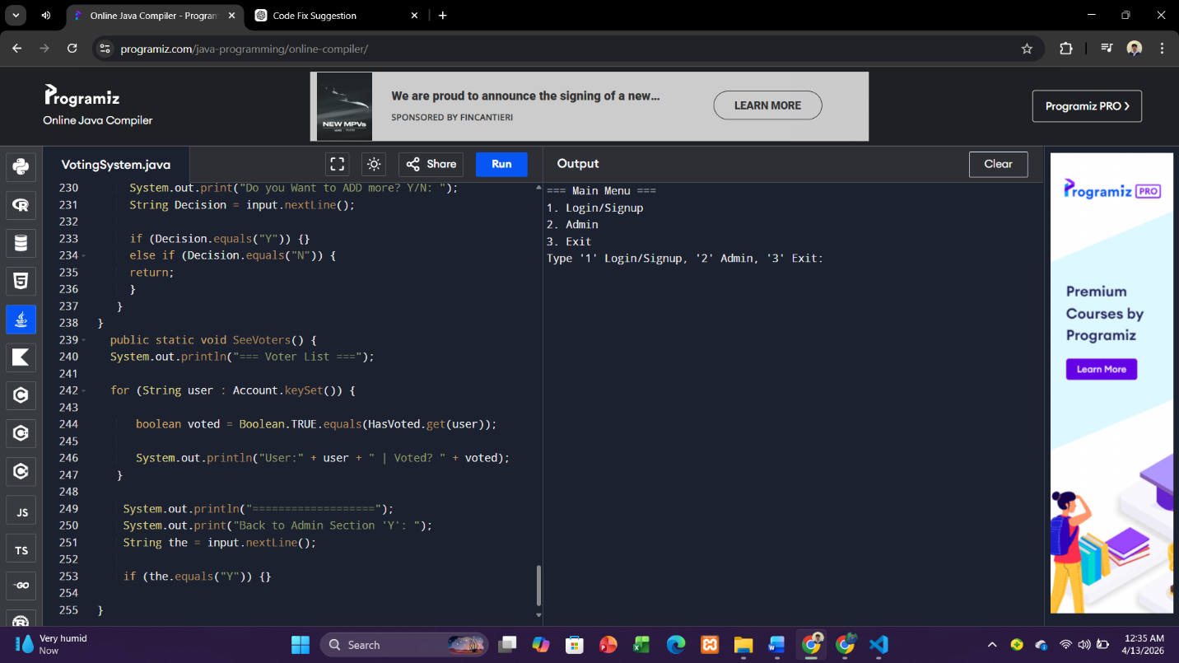

References

ACE Electoral Knowledge Network. (2023). Elections and technology. ACE Electoral Knowledge Network. https://aceproject.org/ace-en/topics/et/explore_topic_new
International Institute for Democracy and Electoral Assistance. (2015). Introducing electronic voting: Essential considerations. International IDEA. https://www.idea.int/publications/catalogue/introducing-electronic-voting-essential-considerations
Electronic voting. (n.d.). In Wikipedia. https://en.wikipedia.org/wiki/Electronic_voting
ACE Electoral Knowledge Network is described on Wikipedia and is associated with International IDEA, IFES, and UNDESA. (n.d.). In Wikipedia. https://en.wikipedia.org/wiki/ACE_Electoral_Knowledge_Network

